HOME WORK
Reg.Number :-SUE/IS /20/ICT/084 Submission Due: 2023-06-15

Exercise 01:
1. Write a java program to demonstrate the Default Constructor.
a. Create a class Default.
b. Initialize two variables called ‘x’ and ‘y’. Make a as the integer variable and b as the
Boolean variable.
c. Create an object deconstructor.
d. Access the objects through reference variables
Answer:-
public class Default {

int a;
boolean b;

public void Display() {

System.out.println("X is "+a);
System.out.print("Y is "+b);
}

public static void main(String[] args) {

Default D1 =new Default();

D1.a=1;
D1.b=true;
D1.Display();

}
}

Output:-
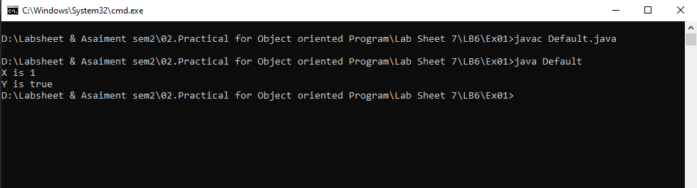

2. Write a java program to demonstrate the Non Argument Construtor.
a. Create a class University.
b. Include a constructor to initialize a name for the object.
c. Modify the program to bring the main method to a separate class TestYourUniversity.
d. Create one object.
e. Access the object / Display the object.
Answer:-
University.java

public class University{

String University_Name;
String University_ID;

public University(){

University_Name="South Eastern University ";
University_ID ="U001";
}

}

TestYourUniversity.java

public class TestYourUniversity{
public static void main(String[]args){

University U1 =new University();

System.out.println("University Name "+U1.University_Name);
System.out.println("University ID "+U1.University_ID);
}
}

Output:-

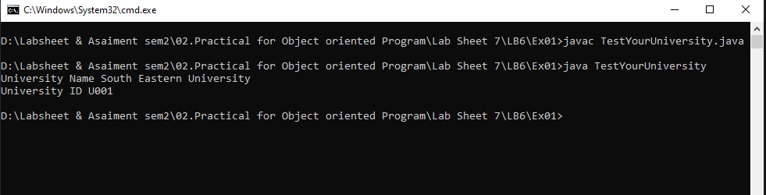

3. Write a java program to demonstrate the Parameterized or User Defined Construtor.
a. Create a class Student with the attribiutes student number, marks and fees.
b. Include a construtor to initialize the user defined values for the object and display
metod to display the object values.
c. Create one object.
d. Bring the main method to a separate class MyStudent.
Answer:-

Student.java

public class Student {
String Student_number;
int Student_marks;
int Student_fees;

public Student(String number,int marks,int fees){

Student_number = number;
Student_marks =marks;
Student_fees=fees;

}
}

MyStudent.java

public class MyStudent {

public static void main(String[] args) {
Student S1 = new Student("S001", 87, 1000);

System.out.println("Student Number " + S1.Student_number);
System.out.println("Student Marks " + S1.Student_marks);
System.out.println("Student Fees " + S1.Student_fees);

}
}

Output:-
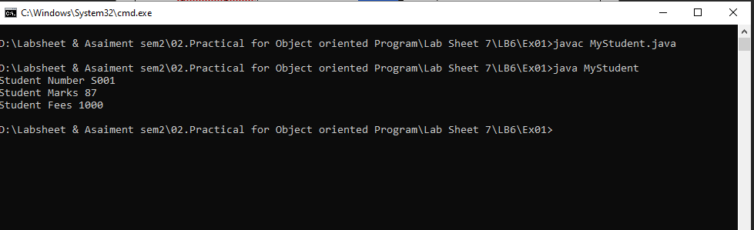

Exercise 02:
a. Create the class Employee with the attributes employee number, basic salary, allowance
and net salary.
b. Create a construtor and initialize the employee object with the input data values (Employee
number and basic salary).
c. Included the methods to do the following.
• Calculation() – To calculate the net salary with the following contions.
Basic salary > 100, 000
Allowance – 10%
Basic salary <= 100, 000
• Display() – to display the calculation with employee number
d. Create one object.
e. Bring the main method to a separate class TestEmployee

Answer:-
Employee.java

public class Employee {

String Employee_Number;
double Basic_Salary;
double Allowance;
double Salary;

public Employee(String Number, double Salary) {

Employee_Number = Number;
Basic_Salary = Salary;

}

public void Calculation() {

if (Basic_Salary > 100000) {

Allowance = (0.1 * Basic_Salary);

} else {

Allowance = 0;
}
Salary = Allowance + Basic_Salary;

}

public void Display() {

System.out.println("Employee Number:- " + Employee_Number);
System.out.println("Employee Basic Salary:- " + Basic_Salary);
System.out.println("Employee Allownce:- " + Allowance);
System.out.println("Employee Salary:- " + Salary);
}

}

TestEmployee.java

import java.util.Scanner;

public class TestEmployee {

public static void main(String []args){

String Nunmber;
double Salary;

Scanner scanner =new Scanner(System.in);

System.out.print("Enter Employee Number:-");
Nunmber =scanner.nextLine();
System.out.print("Enter Employee salary:-");
Salary=scanner.nextDouble();
System.out.println("");

Employee Em1 =new Employee(Nunmber,Salary);

Em1.Calculation();
Em1.Display();

}
}

Output:-

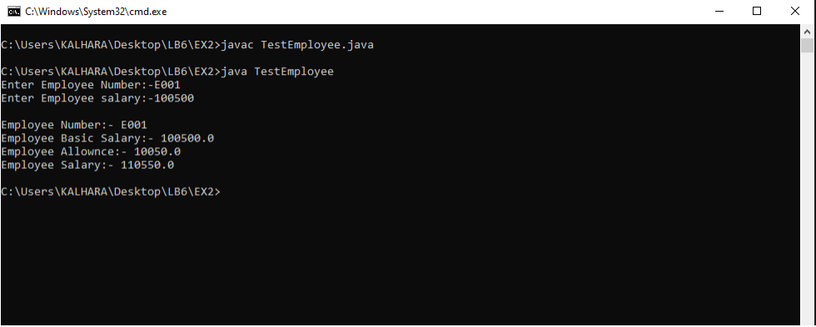

Exercise 03:
a. Create the class Student including the attributes number, namen marks for three subjects,
total, average and grade.
b. Create a constructor and initialize the student obejcts with the input data values (Number,
name and three marks).
c. A method to calculate the total. Average amd grade (pass or fail).
d. A method to display the calculations with the student number and name.
e. Create one object.

Answer:-
Student.java

import java.util.Scanner;
public class Student{

String Number;
String Namen;
int [] Marks;
int Total =0;
float Average;
String Grade;

public Student(String number,String Name, int[] marks){
Number =number;
Namen =Name;
Marks =marks;

}

public void calculateTotal(){

for (int i=0;i<3;i++){

Total = Total +Marks[i];
}

}

public void calculateAverage() {
Average =Total/3;
}
public void calculateGrade() {
if(Average >=45){
Grade ="Pass";
}
else{
Grade ="Fail";
}
}

public void Display(){
System.out.println("Students Number:- " + Number);
System.out.println("Students Name- " + Namen);

for(int i=0;i<3;i++){
System.out.println("Students Subjacet "+(i+1)+"Mark:-"+ Marks[i]);
}

System.out.println("Students Total Marks:- " + Total);
System.out.println("Students Marks Average:- " + Average);
System.out.println("Students Grade:- " + Grade);
}

}

TestStudent.java

import java.util.Scanner;

public class TestStudent {

public static void main(String[] args) {

String Name;
String Number;
int [] marks =new int[3] ;

Scanner scanner = new Scanner(System.in);

System.out.print("Enter Student Name:-");
Name = scanner.nextLine();
System.out.print("Enter Student Number:-");
Number = scanner.nextLine();

for(int i=0;i<3;i++){

System.out.print("Enter Student Suject "+(i+1)+" Marks:-");
marks[i] =scanner.nextInt();
}

//int [] marks ={85 ,55 ,45};

Student S1 = new Student(Number, Name,marks);

System.out.println("");

S1.calculateTotal();
S1.calculateAverage();
S1.calculateGrade();
S1.Display();

}

}

Output:-

